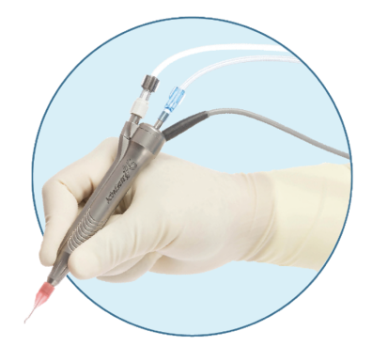
Design
Proposal

BME 180 Senior Design
University of California, Irvine

Team: Isaac Hoyt, Brian Ngo, Matthew Luong, Yolanda Gomez, Landon Stein, Tandol Jerthsattayanukul
Mentors: Camille Lo Porciuncula, Tom Schacht, Diego Cueto

Clinical Need
This project holds significant value over a critical component of eye surgery: handpiece quality and safety. The Active Sentry handpiece is a component of Alcon’s Centurion eye surgery system [4]. After handpieces are assembled, they undergo a testing procedure that includes a fluid flush of the device. Any particles suspended in the fluid are captured by a filter, which will be examined to determine the quantity and size of any machining debris remaining inside the handpiece. Presently, trained technicians are required to manually evaluate particulates generated in the device testing process. As the demand for these devices grows, current testing methods have been proven to scale poorly compared to production needs and goals. By advancing particulate counting technology, we not only aim to enhance our quality control processes but also reduce costs, increase yield, and contribute to safer, more effective surgical procedures globally.

Current Solutions
The current method for assessing particulate count in an Alcon’s handpiece involves microscopic particulate testing. In this process, uncontaminated water is flushed through the handpiece, separating and clearing out metal particulates from the handpiece, and pushed through a membrane filter that will catch the particulates [1]. The membrane is then manually examined under a microscope, where technicians use a microscope, aided by a digital camera, to identify and count the metal particulates [1].
This testing process is very crucial since the Active Sentry handpiece is used in sensitive medical procedures such as eye surgery, the device is directly interacting with the human body [2]. Testing ensures that devices are free from particular contamination to prevent potential risks including inflammation or infection in patients’ eyes. Leftover particles in the Active Sentry handpiece due to errors in the testing process can lead to retinal damage [2]. Metal particles can irritate delicate tissues of the retina during a procedure, leading to tears or even retinal detachment [2]. Contaminating particles can also increase the wear and tear on the device over time, reducing its lifespan and operational efficiency. The testing process is necessary to maintain the device’s longevity and functionality.
This method requires specialized skills and is very time-consuming [1]. Due to relying on human interpretation, delivering variable results based on the observing technician, this method is tedious while also being susceptible to error and inefficiency [1]. The microscopic particulate count test's inefficiencies can substantially impact several aspects of healthcare delivery. Since the test is time-consuming, it delays the availability of Active Sentry Handpieces for surgical procedures. If the device were to malfunction due to the inefficiency of the testing process, the reputation of Alcon would be heavily impacted. Device malfunction that compromises patient safety can lead to public concerns over the reliability and safety of Alcon’s Active Sentry Handpiece. The loss of confidence in healthcare providers and patients for Alcon’s product would lead to the loss of market shares while stock value would decrease along with it.

Value Proposition
We plan to improve upon the Microscopic particulate count test since the current process places a significant burden on technicians due to its reliance on manual operation, leading to inconsistent results and delays in quality checks. Transforming the microscopic particulate count test into an automated particulate count test will be the main focus of this project. Augmenting this test with artificial intelligence could be a huge step moving forward in improving testing process efficiency and quality. Particle extraction and filtration are expected to remain the same as we are improving upon the identification system of the particulates – the flush and filter process is outside the scope of our project. The main focus of this project is to create a device that can reduce the dependency on technicians in the testing process while minimizing human error.
AI algorithms can be designed to adapt to different particle characteristics, improving detection accuracy and process efficiency. This autonomous system could significantly accelerate testing times, increase repeatability, and ensure high-precision results [1]. An improvement upon this process will open up a bottleneck within the manufacturing process of Alcon’s handpieces, allowing for faster identification, and increased yield, and most importantly, it reduces the need for highly skilled manual labor, allowing technicians to be placed elsewhere in the process to further increase production.
This transformation from manual inspection to automated inspection will significantly benefit technicians by reducing manual workload and variability [1]. With the reduction in routine manual tasks, technicians can focus more on complex aspects of the manufacturing and development process which could lead to greater job satisfaction. The long-term savings in labor costs, coupled with the reduction in errors, can be financially beneficial for hospitals [3]. In addition, patients will receive the best benefit out of this process by enabling faster quality assurance of Active Sentry Handpiece. Automated systems can detect particulates more reliably and more accurately, reducing the risk of complications from contaminated medical devices in which higher standards of patient safety during medical procedures will be ensured [1].
With a growing demand for precision and efficiency in medical device quality assurance, our automated system holds significant market potential. Unlike existing solutions, our product leverages AI to deliver unmatched accuracy and scalability, making it an attractive choice for medical device manufacturers. By bridging the gap between manual labor and advanced automation, our product meets the critical need for scalable and reliable particulate contamination testing in the medical device industry.

Design Selection
The current three design choices our team has selected to approach the current particulate counting process are the following:

Light Obscuration
Light obscuration works by passing a dilute stream of particles in a liquid suspension between a light source and a detector. The light source, being a laser diode, illuminates individual particles in the stream to generate a shadow or blockage of light on the detector. The blockage is called “obscuration”, and the detector measures the reduction in light intensity [5]. The detector will then process the measured signal and display a calibration curve. The curve can be read to quantify particles and their size. Because it counts the particles in a fluid sample, light obscuration particle counting would take place before the irrigation fluid is filtered. Light obscuration particle counters operate automatically, so user input is minimal [6].
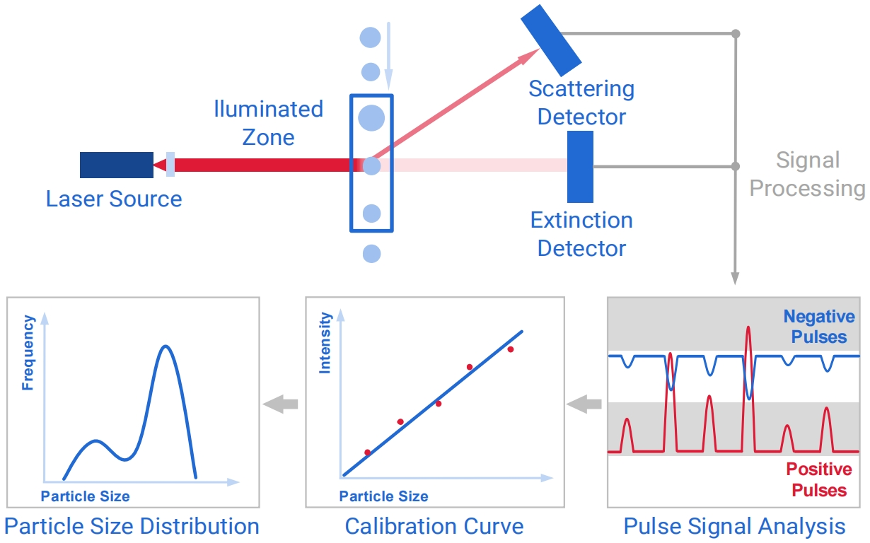
Light Microscope Filter Inspection
Figure 1: Light Obscuration Particle Testing
Source: [5]
During production, the handpiece is flushed with distilled water to extract particulates. At present, the particles generated during handpiece testing are separated from the irrigation fluid with a membrane filter. A technician places the filter on a microscope slide and inspects the filter with a light microscope. The technician counts the particles by eye and categorizes them by size in accordance with Alcon’s manufacturing operating procedure [7]. An automatic solution would count the particles with a software program that analyzes the images produced by the light microscope. This program would need to accurately threshold the particles from the filter background, and then calculate the number of particles and estimate their sizes.
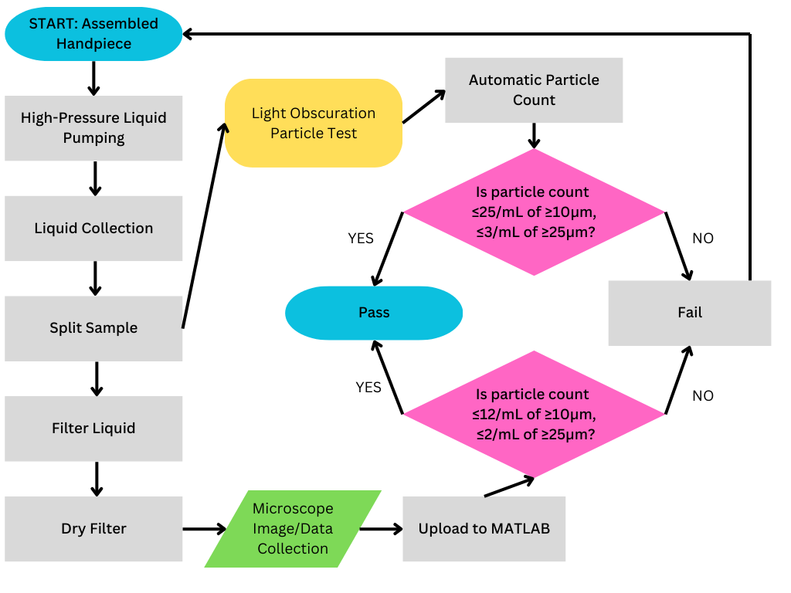
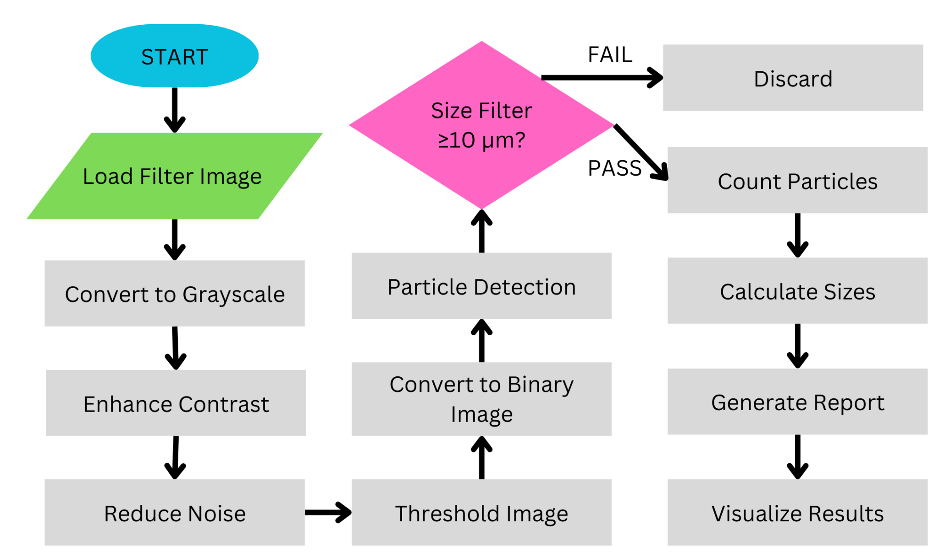
Figure 3: Process Flowchart
Figure 2: Counting Software Workflow

White Light Interferometry Filter Inspection
Light interference occurs when two waves of light converge constructively or destructively, causing the amplitude of the new combined wave to increase or decrease. White light interferometry utilizes this phenomenon to map the surface roughness of a sample. A source of white light is shined over the sample and reference surfaces. A beam splitter separates the light into reference and measurement beams. The reference beam is passed through the reference mirror, and the measurement beam is reflected from the sample surface. The returning beam is reflected and relayed by the beam splitter to a CCD image sensor and forms an interference pattern of the sample surface’s topography [8]. By analyzing the surface of the topography, particulates can be identified and measured in a 3D environment. White light interferometry would be used as an alternative imaging method for the microscope count test. This method would be identical to the microscope count test, except that the white light interferometry microscope can output an accurate topology map of the membrane filter being imaged, which can be used to more accurately evaluate particles. This would also necessitate a different data analysis program, which would threshold and count particles based off of the topology of the membrane filter instead of a photograph from the light microscope.

Design Requirements
A list of design requirements is needed to decide which method would fit best with the scope of our project. Each design requirement is given a justification to demonstrate its relevance with our goals with the project.
Design Requirements | Justification
Autonomous | Once the data is collected from our imaging method, we will write a script that would analyze the data to make the particulate analysis autonomous.
Time-efficient | The current time it takes to analyze each handpiece manually is approximately 30-40 minutes. To increase production, the time it takes to test each handpiece should be reduced up to 90%.
Identifies particle count per given area, particle type, and individual size | The basis of the script is to receive imaging data and do the following:  - Quantify the particulate count per given area  - Identify what type of particulate it is (i.e. metal, plastic, etc.)  - Measure the size of each individual particle
Determines if handpiece is safe for use, provides feedback, and states the size of largest particle if it is greater than 4.00 mils | The system needs to determine if the handpiece is ready for production given Alcon’s testing criteria.  To comply with Alcon’s particulate testing criteria, we need the system to provide a report on all particulates that were detected with their sizes stated.
Records necessary information of handpiece if test is passed or records the test number and if handpiece fails | System needs the documentation of each handpiece once it has passed the test.  If the test failed, then we need to record the number of testing exposures and determine if the handpiece should be discarded to comply with Alcon’s testing criteria.
Integration of AI | For accurate precision, machine learning software can improve the accuracy of the script we are using to analyze particulate.
With our design requirements stated, we need to list our each advantage and disadvantage of the three stated design methods.
 | Pros | Cons
Light Obscuration | - Rapid analysis (results in seconds)  - Automated process  - Easy to read results  - High resolution particle sizing and counting | - Limited information about particle morphology  - Unable to categorize particles  - Unlikely AI can be utilized  - Lacks novelty
Light Microscope Filter Inspection | - Detailed morphology of particles  - Large particle detection  - Qualitative analysis  - Easy to integrate/modify with current methods  - Faster than manual analysis | - Highly dependent on software code for accurate interpretation of particle morphology
White Light Interferometry | Fast analysis (results in minutes)  - Non-destructive imaging technique  - 3D profiling for detailed analysis  - Versatile with sample types | - Prone to environmental noise  - Irregular shapes can result in ambiguous topology  - Reflective surfaces can cause unwanted reflections and scattering  - Interferes with the accurate interpretation of particles  - Lacks novelty

Fulfilling Design Requirements
The following table contains the three proposed designs and how well they are equipped to address the requirements our team defined. The design requirements are listed from top to bottom on the left-most column, and each method is listed from left to right starting from the second column.
 | Light Obscuration | Light Microscope Filter Inspection | White Light Interferometry
Autonomy | Fully automated, minimal amount of input | Software code allows for automation | Fully Automated with image processing and software code
Speed of Analysis | Results given in seconds | Moderate; faster with automation system | Results given in minutes
Precision & Accuracy | Limited for transparent particles | High with morphological analysis | Extremely precise, (subnanometer scale)
Particle Size and Morphological Detection | Size only, no morphological data | Size, shape, and material detection | 3D particle shape and surface mapping
Data Integration and Reporting | Easy reporting via calibration curve | Pass/fail thresholds and records kept | Automated reports with detailed maps
Integration of AI | Unlikely AI can be utilized to any effect | AI can be used to enhance the precision of the software code | AI can be used to enhance the accuracy of the software code
Light Microscope Filter Inspection fulfills our design requirements the best because of its ability to be easily integrated to Alcon’s current infrastructure while producing a much faster production and highly detailed particle information such as the material, size and shape. In addition, the Light Microscope Filter allows for a novel design to be integrated in the inspection process, unlike the White Light Interferometry (WLI), this method will allow for the team’s focus to expand on the software rather than expensive hardware, and rigorous training that will have to integrated in the WLI approach. With Light Obscuration, the information regarding the morphology of the particulate is limited to size only. The lack of particulate type identification makes this method problematic as the team needs to analyze metal particulates.

Advantages over the Current Solution
All three proposed designs build on the current state of the art solution for metal particulate counting by incorporating automation, which significantly improves speed and efficiency. Currently, Alcon relies on manual inspection using microscopes, requiring specialists to analyze slides containing fluid flushed through the handpiece walls. This process can take up to 30 minutes per sample, introducing human error and inconsistencies. The proposed methods eliminate these issues by automating particle analysis, enabling faster, more precise results while ensuring compliance with industry standards.
Light obscuration excels in speed and automation, delivering almost instant results by counting particles through light blockage. Unlike the manual process, it requires minimal technical setup, allowing operators to focus on result interpretation rather than labor-intensive inspections. It complies with industry protocols such as ISO 4406, making it suitable for various industrial applications. Additionally, light obscuration is non-destructive, ensuring that handpiece samples remain intact during testing which is a critical factor in maintaining device quality [9].
The optimized microscopic particle count test offers a more detailed analysis compared to manual microscopy. It uses AI-powered imaging to detect particle size, shape, and material composition, addressing the limitations of human inspection. Its ability to integrate AI ensures repeatable and consistent results while supporting industry standards such as ISO 10993 and USP 788. By automating the manual evaluation process, this method not only reduces inspection time but also enhances data accuracy and reliability [10][11].
White light interferometry (WLI) provides unmatched precision by measuring surface particles at sub-nanometer resolution. This technology can capture complex topographical features missed by traditional methods, offering a comprehensive surface map that includes particle depth and shape. Its fully automated data processing system generates detailed reports, eliminating the need for manual interpretation. This capability allows for a more thorough evaluation of particulate contamination in eye surgery handpieces, ensuring greater accuracy and compliance [8].
These proposed methods surpass Alcon's current manual process by enhancing speed, reducing human error, and enabling large-scale, precise inspections. Their integration of AI, advanced imaging, and automation ensures a streamlined, scalable solution for ensuring the cleanliness and sterility of surgical handpieces.

Disadvantages over the Current Solution
While the proposed designs improve automation and precision over Alcon's current manual inspection process, they also have notable limitations. Light obscuration struggles with transparent or irregularly shaped particles because it relies on light blockage, limiting its effectiveness in detecting complex particulate compositions [10]. Additionally, it faces challenges with high-viscosity fluids, where inconsistent flow can affect accuracy [10]. These drawbacks reduce its applicability in environments requiring detailed particle characterization.
The microscopic particle count test and white light interferometry (WLI) present different challenges. The microscopic test has high initial setup costs due to advanced imaging systems and AI software. It also generates large datasets, requiring extensive processing and storage capabilities [10][11]. WLI, while highly precise, involves significant expenses for equipment, maintenance, and operator training. Both methods are environmentally sensitive: vibrations, lighting inconsistencies, and air turbulence can distort results, necessitating controlled lab settings [11]. These factors highlight the trade-offs between technological advancement and practical implementation.

Selected Design
After evaluating the proposed methods, our team selected the Optimized Microscopic Particle Count Test as the most suitable design for automating metal particulate counting in Alcon’s handpieces. This decision is based on its balance of precision, scalability, and integration potential within Alcon’s existing processes. The microscopic particle count test offers a comprehensive solution that aligns well with the project’s design criteria. Keeping the white light interferometry as an alternative solution as it can output an accurate topology map of the membrane filter being imaged, which can be used to more accurately evaluate particles.
The automated test provides precise particle size and shape analysis through AI-powered image processing such as detailed morphological assessments, including size categorization and material differentiation. Moreover, it can operate within Alcon’s current infrastructure, leveraging existing imaging equipment with minimal hardware upgrades. Lastly, automation reduces inspection time from an average of 30 minutes to just a few minutes per sample, enabling higher throughput while minimizing human error. For these reasons, our team determined that the optimized microscopic particle count test is the most practical and effective design for Alcon’s production needs.

Design Project Plan
This Design Project Plan outlines a strategy for the development and validation of an automated particle count test process for use in the manufacture of Alcon’s ActiveSentry Handpiece. Our design and qualification plans take guidance from standards bodies, including the International Organization for Standardization (ISO), the International Electrotechnical Commission (IEC), the American Society for Testing and Materials (ASTM) and the United States Pharmacopeia (USP). Key project milestones include an initial prototype developed by the end of February, technical requirement-aligned qualification testing throughout March, and a final prototype completed and implemented in live production by April.
Our group will perform risk management throughout our engineering project. ISO 14971 stipulates the risk management process for the development of medical devices [12]. Our project will adhere to the framework that it provides for manufacturers to identify, evaluate, and mitigate risks throughout the lifecycle of a medical device. As part of our risk management plan, we will outline the scope of our device and assign responsibilities for risk management. We will make use of failure mode and effect analysis to identify, assess, and prevent failure modes for our particle evaluation program. This requires that our group identify hazards, and then estimate and evaluate the risks associated with each identified hazard, before taking control measures to mitigate unacceptable risks. The entire risk management process will be documented within a risk management file that will include our risk management plan, as well as the results of our risk analysis, evaluation, and control measures [12].
Additional biocompatibility evaluations, outside of those already carried out by Alcon during the validation of ActiveSentry, do not fall within the purview of our project. ISO 10993 Biocompatibility standards outline how to evaluate the biocompatibility of medical devices within a risk management process [13]. Throughout the development of the ActiveSentry handpiece, “Alcon conducted biocompatibility testing on the patient-contacting accessories and met ISO 10993 requirements for chemical characterization, cytotoxicity, sensitization, irritation, and acute systemic toxicity” [14]. Our project will not introduce any new materials to the handpiece, and will uphold Alcon’s existing standards for particle contamination.
IEC 60601 Medical electronics safety standards set out the requirements for the safety and performance of medical electrical equipment. Alcon’s ActiveSentry handpiece measures pressure changes in the anterior chamber of the handpiece, and responds by adjusting the pressure on the irrigating solution bag, to maintain a healthy intraocular pressure. This is an example of the physiologic closed-loop controller systems (PCLS) whose development EIC 6061 governs [15]. Similarly to ISO 10993 however, while the IEC 6061 standard applies to the ActiveSentry handpiece, it holds little relevance for our project; Changes to the particle counting process, as long as the same particle contamination standards are upheld, are unlikely to affect the electronic components in the ActiveSentry handpiece’s PCLS.
Multiple ASTM F04.15 Material and Test Method standards apply to various components of the Alcon ActiveSentry handpiece, but the most relevant for our project is F3127-22: Standard Guide for Validating Cleaning Processes Used During the Manufacture of Medical Devices [16]. We will consult and follow this standard as we undergo qualification testing. Alcon has existing documentation on the procedure for assembling and testing the activesentry handpiece, which complies with F3127-22. We will identify where our device makes changes to Alcon’s current testing process, and ensure that any changes that we make abide by F3127-22. In particular, we will consult its guidelines in section 8, Analytical Methods, to validate the suitability of analytical methods used to detect contaminants [16].
Another technical standard relevant to our device is United States Pharmacopeia <788> Particulate Matter in Injections [17]. Although it is written to test injectable products, this standard is frequently used to evaluate the particulate loads of medical devices [18]. USP <788> delineates two procedures for examining injection samples for sub-visible particles[18]. Method 1 (Light Obscuration Test) aligns with the Light Obscuration design choice discussed earlier. Method 2 (Microscope Particle Count Test) aligns with Alcon’s current evaluation method, as well as both the Light Microscope Filter Examination and White Light Interferometry Filter Examination design choices mentioned above, but only insofar as the sample is prepared. USP <788> Method 2 describes a manual counting process [10], whereas our second two design choices are intended to evaluate particles automatically.
As we proceed with the design and testing of our prototype, we anticipate qualification testing will take approximately a month and a half. This time will allow us to thoroughly evaluate the functionality and performance of our product under the required conditions. Should our device fail the qualification test, we have budgeted an additional month for redesign efforts. This timeline ensures sufficient flexibility to address any issues and implement necessary improvements effectively.
Our prototyping efforts will span the entirety of the winter quarter, during which we will also conduct extensive research utilizing external resources and insights from Alcon. Training to operate the equipment required for qualification testing is scheduled to begin in early March. To support this, we plan to draft our qualification test plan in January, ensuring we have a clear and actionable framework in place for testing.
Given the software-based nature of our product, we are not building physical components at this stage. Instead, we have set two key checkpoints for software development: the first at the end of February, where we will present our prototype to mentors for initial feedback, and the second at the end of March, where we will showcase the revised prototype based on feedback, preparing for device implementation in live production. As a result, material ordering and lead times are currently non-applicable to our project.
Customer interviews are planned for the spring quarter, during the implementation phase of live production. These interviews will either take place a month before the spring quarter or during it, to ensure we gather critical feedback for final adjustments. Team meetings are arranged as needed, though coordinating all six team members can sometimes be challenging. Currently, we operate in two groups of three: one focusing on mentor communication and the other on the design process. Information is regularly relayed between groups to maintain alignment. Advisor meetings, while presently impromptu, are expected to transition to a biweekly schedule as we finalize arrangements with our newly assigned mentor. This structured approach aims to ensure consistent progress and effective collaboration throughout the project timeline.

Gantt Chart
A Gantt Chart is used to track the progress of the team. The chart below provides an overview of major tasks throughout the school year. The calendar is split by month, and each week is numbered. The light blue blocks represent planned tasks/dates the task will be worked on, and the dark blue indicates the actual dates the task was worked on.

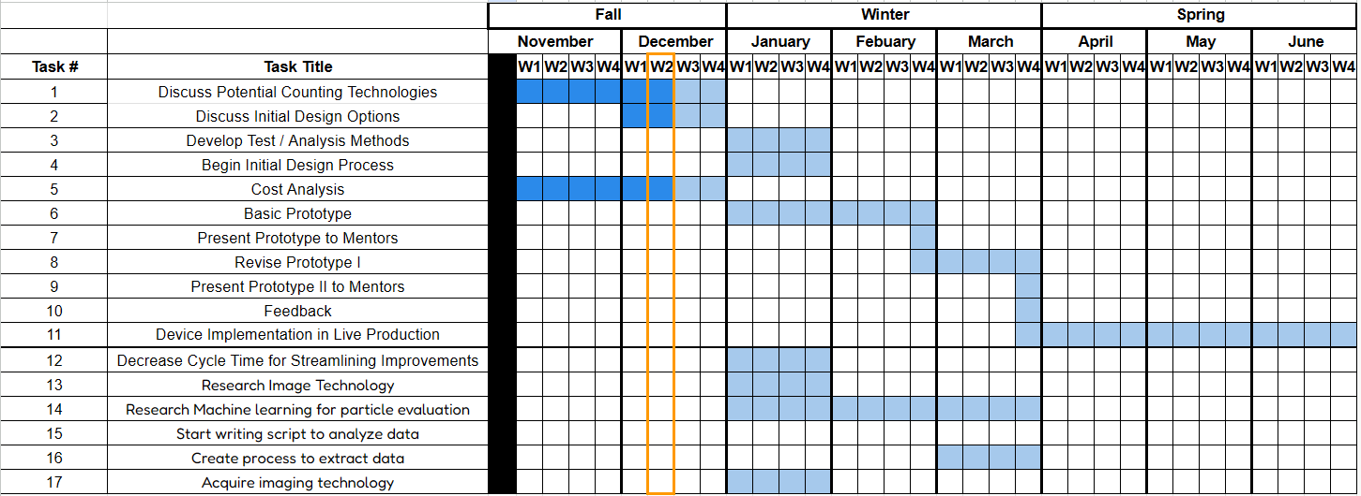
At the top of the Gantt chart, tasks are grouped based on each quarter. The period outlined in the orange vertical bar indicates the current progress of the project.

Proposed Budget

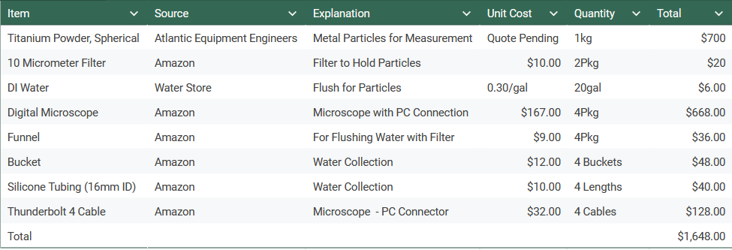

Learning Outcomes

Student Learning Outcome/Project Constraint | We considered  this, but it was not relevant in our  project (Yes/No?)  KEY:  YES=NOT RELEVANT  NO=RELEVANT | It was relevant in our project  (Yes/No?) | Location in Plan Where this is Addressed
Apply principles of engineering | NO | YES | Clinical Need, Current Solutions, Value Proposition, Design Selection, Design Project Plan, Gantt Chart, Proposed Budget
Apply principles of science | NO | YES | Clinical Need, Current Solutions, Value Proposition, Design Selection, Design Project Plan, Gantt Chart, Proposed Budget
Apply principles of mathematics | NO | YES | Clinical Need, Current Solutions, Value Proposition, Design Selection, Design Project Plan, Gantt Chart, Proposed Budget
Constraint: Design with  public health | NO | YES | Clinical Need, Value Proposition, Design Selection, Design Project Plan
Constraint: Design with safety  and welfare consideration | NO | YES | Clinical Need, Current Solutions, Value Proposition, Design Selection, Design Project Plan,
Constraint: Design with global  consideration | YES | NO
Constraint: Design with social  and cultural consideration | YES | NO
Constraint: Design with  environmental  consideration | YES | NO
Constraint: Design with economic consideration | NO | YES | Clinical Need, Current Solutions, Value Proposition, Design Selection, Design Project Plan, Proposed Budget
Constraint: Design with  manufacturability consideration | NO | YES | Current Solutions, Value Proposition, Design Selection, Design Project Plan, Gantt Chart, Proposed Budget
Constraint: Design with ergonomic consideration | NO | YES | Clinical Need, Current Solutions, Value Proposition, Design Selection, Design Project Plan
Constraint: Used ethical  considerations to inform solution in global context | NO | YES | Clinical Need, Current Solutions, Value Proposition
Constraint: Used ethical  considerations to inform solution in economic context | NO | YES | Clinical Need, Current Solutions, Value Proposition
Constraint: Used ethical  considerations to inform solution in environmental context | YES | NO
Constraint: Used ethical  considerations to inform solution in societal context | NO | YES | Clinical Need, Current Solutions, Value Proposition
Team members who provided leadership | NO | YES | Everyone 🙂
Team members who provided collaborative and inclusive  environment | NO | YES | Everyone 🙂
Team members and activities who established goals, planned tasks, and meet objectives | NO | YES | Everyone 🙂
Used appropriate standards and experimentation | NO | YES | Current Solutions, Design Selection, Design Project Plan
Analyzed and interpreted data to draw conclusions | NO | YES | Current Solutions, Value Proposition, Design Selection, Design Project Plan, Proposed Budget
Acquired and applied new knowledge as needed for your project | NO |  | Current Solutions, Value Proposition, Design Selection, Design Project Plan, Gantt Chart, Proposed Budget
Applied appropriate engineering standards to your design | NO |  | Design Selection, Design Project Plan
Applied appropriate FDA standards to your design | NO |  | Design Project Plan

References
[1] K. I. Kling, "Medical Devices and Particulates," SAXOCON A/S. https://www.saxocon.com/wp-content/uploads/2022/01/Medical-Devices-and-Particulates-White-Paper.pdf.
[2] A. P. Brezin, “Surgical Performance of CENTURION Vision System with Active Sentry,” Cataract & Refractive Surgery Today.
https://crstoday.com/articles/surgical-performance-of-centurion-vision-system-with-active-sentry/surgical-performance-of-centurion-vision-system-with-active-sentry.
[3] J. McCrary, “7 Benefits of Automation in Healthcare,” Leadsquared. 2023.
https://www.leadsquared.com/industries/healthcare/7-benefits-of-automation-in-healthcare/.
[4] “Alcon Centurion® Vision System | Alcon Professional,” MyAlcon. https://www.myalcon.com/professional/cataract-surgery/surgical-equipment/centurion/
[5] “How to calculate the number of particles and measure the particle size with the optical particle counter,” Bettersize Instruments Ltd. https://www.bettersizeinstruments.com/learn/bettersize-wiki/measure-the-particle-size-with-the-optical-particle-counter/
[6] “Light Obscuration, Optical Particle Detection,” www.beckman.com. https://www.beckman.com/resources/industry-standards/usp-787/light-obscuration-optical-method-for-particle-detection
[7] Alcon, MANUFACTURING TEST PROCEDURE FOR HANDPIECE METAL PARTICULATE. Irvine, CA: Alcon.
[8] “White Light Interferometers | Instruments Used For Roughness Measurements | Introduction To Roughness | KEYENCE America,” Keyence.com, 2024. https://www.keyence.com/ss/products/microscope/roughness/equipment/interferometers.jsp (accessed Dec. 10, 2024).
[9] Ripple, D. C., & DeRose, P. C. (2018). Primary Determination of Particle Number Concentration with Light Obscuration and Dynamic Imaging Particle Counters. Journal of Research of the National Institute of Standards and Technology, 123. https://doi.org/10.6028/jres.123.002
[10] Thomas, C., Spatayeva, T., Yu, D., Loh, A., Yim, U. H., & Yoon, J. (2024). A comparison of1 current analytical methods for detecting particulate matter and micro/nanoplastics. Applied Physics Reviews, 11(1). https://doi.org/10.1063/5.0153106
[11] Ireland, K. (n.d.). Particulate matter monitoring instruments https://dec.alaska.gov/air/air-monitoring/instruments-sites/particulate-monitors/
[12] International Organization for Standardization, “ISO 14971:2019,” ISO, Dec. 2019. https://www.iso.org/standard/72704.html
[13] ISO, “ISO 10993-1:2018,” ISO, 2018. https://www.iso.org/standard/68936.html
[14] G. Balachandar, “510(k) Summary: K233876 UNITY VCS, UNITY CS,” FDA, 2024. Accessed: Dec. 09, 2024. [Online]. Available: https://www.accessdata.fda.gov/cdrh_docs/pdf23/K233876.pdf
[15] Medical electrical equipment– Part 1-10: General requirements for basic safety and essential performance – Collateral Standard: Requirements for the development of physiologic closed-loop controllers. Geneva, Switzerland: International Electrotechnical Commission, 2007. Available: https://webstore.iec.ch/en/publication/2603
[16] Standard Guide for Validating Cleaning Processes Used During the Manufacture of Medical Devices. West Conshohocken, PA: ASTM International, 2022.
[17] United States Pharmacopeia , “<788> Particulate Matter in Injections,” Jun. 29, 2012. https://www.uspnf.com/sites/default/files/usp_pdf/EN/USPNF/revisionGeneralChapter788.pdf
[18] W. Kopesky, “Medical Device Cleanliness Testing – Particle Technology Labs,” Particle Technology Labs, Apr. 20, 2023. https://particletechlabs.com/ptl-press/medical-device-cleanliness-testing-usp-788/

